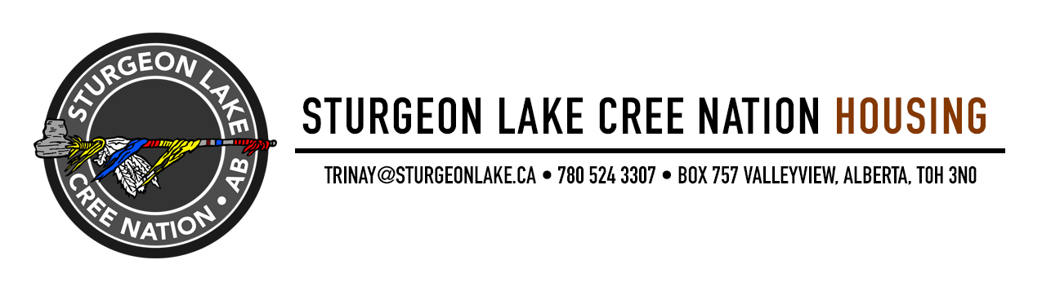

Housing Department is accepting
Housing Applications for

1 – Existing Unit

Unit # 331 – 3-Bedroom on crawlspace (westside)

Housing Applications can be submitted by any of the
following listed below:

- Hand delivered/received to Administration Office
- Facsimile requests to 780-524-2711
Attention: Housing Department.
- Email directly to trinay@sturgeonlake.ca

Deadline for Applications: January 10, 2025

Any additional information contact Trina Young Technical Services Director
@ 780-524-3307 - Monday to Friday 8:30 am to 4:30 pm

